Assignment #1

Question #1

#include<iostream>

using namespace std;

int main()

{

int a, b, c,sum;/*Here we are intialize three variables by taking input */

cout << "Enter the value of a =";

cin >> a;

cout << endl;

cout << "Enter the value of b =";

cin >> b;

cout << endl;

cout << "Enter the value of c =";

cin >> c;

cout << endl;/*This is the condition for isosceles triangle */

if ((sum=a+b)>c||(sum=a+c)>b||(sum=b+c)>a)/*Here we are checking the condition of a triangle */

{

cout << "It is triangle ";

cout << endl;

}

else

{

cout << "it is not Trianle ";

}

if (((a == b) && (a != c) && (b != c)) || (a == c) && ((a != b) && (b != c)) || ((b == c) && (a != c) && (a != b)))

{

cout << "Triangle is ISosceles";

cout << endl;

}

else if ((a == b) && (a == c )|| (b == c)&&(b==a))/*This is the condition for Equilateral triangle */

{

cout << "Triangle is Equilateral";

cout << endl;

}

else if ((a != b) && (a != c) || ((b != c) && (b != a)))/*This is the condition for Scalenes triangle*/

{

cout << "Triangle is Scalenes";

cout << endl;

}

system("pause");

return 0;

}

Output

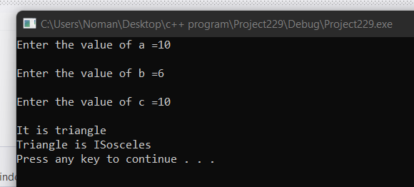

Question #2

#include<iostream>

#include<string>

using namespace std;

int main()

{

int year;

string month;/* Here we are taking month as a input and also year*/

cout << "Enter the month : ";

cin >> month;

cout << "Enter the year : ";

cin >> year;

if (month == "jan")/* this condition is for month januarary*/

cout << "year is" << year << " days are 31" << endl;

if (month == "mar")

cout << "year is" << year << " days are 31" << endl; /*this condition is for month march */

if (month == "Apr")

cout << "year is" << year << " days are 30" << endl; /*similarly the following given below months will follow theirs condition */

if (month == "may")

cout << "year is" << year << " days are 31" << endl;

if (month == "jun")

cout << "year is" << year << " days are 30" << endl;

if (month == "july")

cout << "year is" << year << " days are 31" << endl;

if (month == "Aug")

cout << "year is" << year << " days are 31" << endl;

if (month == "sep")

cout << "year is" << year << " days are 30" << endl;

if (month == "oct")

cout << "year is" << year << " days are 31" << endl;

if (month == "nov")

cout << "year is" << year << " days are 30" << endl;

if (month == "dec")

cout << "year is" << year << " days are 31" << endl; /*Here we have to find Leap year for febuarary month this is special condition */

if (month == "feb")

{

if (year % 4 == 0) /* if month modulus equal to zero then year is Leap otherwise year is not leap year*/

cout << "year is " << year << " and is leap year days are 29" << endl;

else

cout << "Year is " << year << " and year is not leap and days are 28 " << endl;

}

system("pause");

return 0;

}

Output

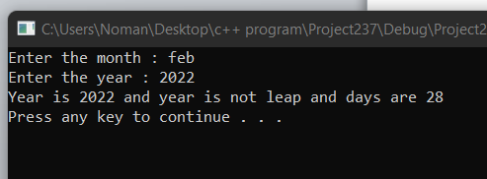

Question #3

Code:

#include<iostream>

using namespace std;

int main()

{ /* First we are intializeing some variables for differnt values*/

int money,five_hundredrupeenote = 0, hundred_rupeenote = 0, fifty_rupeenote = 0, twenty_rupeenote = 0, tenrupee_note = 0, five_rupeenote = 0, two_rupeecoin = 0, one_rupeecoin = 0;

cout << "Enter the Money to take change ="; /*here we are taking input*/

cin >> money;

cout << endl;

five_hundredrupeenote = money / 500; /*This chunk will show five hundred_rupeenote*/

money = money - (five_hundredrupeenote * 500);

hundred_rupeenote = money / 100;

money = money - (hundred_rupeenote * 100); /*This chunk will show hundre rupee note*/

fifty_rupeenote = money / 50;

money = money - (fifty_rupeenote * 50); /*Similarly There are following given below chunks which will perform differnt function*/

twenty_rupeenote = money / 20;

money = money - (twenty_rupeenote * 20);

tenrupee_note = money / 10;

money = money - (tenrupee_note * 10);

five_rupeenote = money / 5;

money = money - (five_rupeenote * 5);

two_rupeecoin = money / 2;

money = money - (two_rupeecoin * 2);

one_rupeecoin = money / 1;

money = money - (one_rupeecoin * 1);

cout << "Total number of notes :" << endl; /*Here we are simply displaying notes*/

cout << "500 rupees notes: " << five_hundredrupeenote;

cout << endl;

cout << "100 rupee Notes :" << hundred_rupeenote;

cout << endl;

cout << "50 rupee Notes :" << fifty_rupeenote;

cout << endl;

cout << "20 rupee Notes :" << twenty_rupeenote;

cout << endl;

cout << "10 rupee Notes :" << tenrupee_note;

cout << endl;

cout << "5 rupee Notes :" << five_rupeenote;

cout << endl;

cout << "2 rupee coin :" << two_rupeecoin;

cout << endl;

cout << "1 rupee coin :" << one_rupeecoin;

cout << endl;

system("pause");

return 0;

}

Output

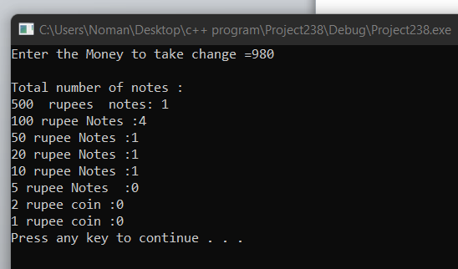

Question #4

Code:

#include<iostream>

using namespace std;

int main()

{

int num1, num2;

cout << "Enter the first Number ="; /*Here we are taking two numbers as a input */

cin >> num1;

cout << endl;

cout << "Enter the second Number =";

cin >> num2;

cout << endl;

char op; /*These are Following operators which will perform differnt Functions according to operator case*/

cout << "Enter the Operator =";

cin >> op;

cout << endl;

switch (op)

{

case '+': /*This Case is for addition */

cout << "The adittion of Numbers is =" << num1 + num2;

cout << endl;

break;

case '-': /*This case is for subtraction*/

cout << " The subtraction of Numbers is = " << num1 - num2;

cout << endl;

break;

case '*': /*This case is for Multiplication */

cout << "The Muliplication of Numbers is =" << num1*num2;

cout << endl;

break;

case '/': /*This case is for division*/

cout << "The Division of Numbers is =" << num1 / num2;

cout << endl;

default:

cout << "Invalid Input";

}

system("pause");

return 0;

}

Output

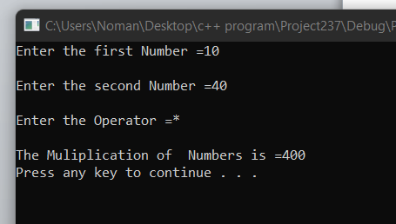

Question #5

#include<iostream>

using namespace std;

int main()

{

int qscore, mscore, fscore, avgscore; /*Here we are taking these scores as input. these score represent mid-term ,quiz and final term*/ /*scores */

char grade = 1;

cout << "Enter the score of Quiz :";

cin >> qscore;

cout << endl;

cout << "Enter the Score of MId-term :"; /*we are entering the Mid-term score here */

cin >> mscore;

cout << endl;

cout << "Enter the Score of final Term :"; /*We are entering the final term score here*/

cin >> fscore;

avgscore = ((qscore + mscore + fscore) / 3)*10; /*Here we are finding the average score */

switch (grade)

{

case 1:

if (avgscore == 90) /*This condition is for grade A*/

{

cout << "Grade:" << "A";

cout << endl;

break;

}

else if (avgscore >= 70 && avgscore < 90)/* This condition is for grade B*/

{

cout << "Grade :" << "B";

cout << endl;

break;

}

else if (avgscore >= 50 && avgscore < 70) /*This condition is for grade C*/

{

cout << "Grade:" << "C";

cout << endl;

break;

}

else if (avgscore < 50)/*This condition is for Grade F*/

{

cout << "Grade :" << "F";

cout << endl;

break;

}

default:

{

cout << "invalid input";

cout << endl;

}

}

cout << "The average score is =" << avgscore;

cout << endl;

system("pause");

return 0;

}

**Output**

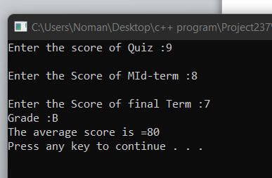

Task #6

Code

#include<iostream>

using namespace std;

int main()

{

char ch;

cout << "Enter the Character :";/* here we are entering a character as a input*/

cin >> ch;

(ch>='a'&&ch<='z')||(ch>='A'&&ch<='Z')?/* we are using ternary operator

*/

cout << "This is alphabet ":/* This is true part */

cout << "it is not alphabet"; /*this is else part*/

system("pause");

return 0;

}

Output

